SAFFRON ÓG ISSUE 2 COMPETITION ENTRY FORM
  NAME THE MASCOTS COMPETITION  NAME FOR FOOTBALL MASCOT:  _______________________________________________________  NAME FOR HURLING MASCOT:  _______________________________________________________  CAPTION COMPETITION  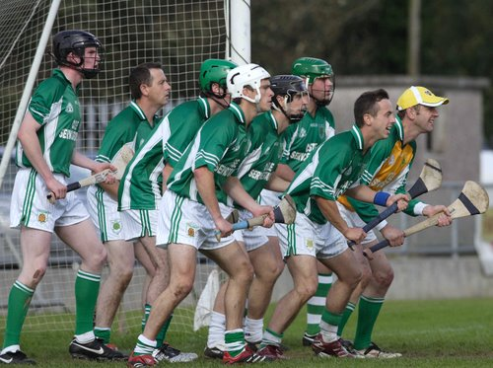  CAPTION: ____________________________________________  _______________________________ ____________ | SEND COMPLETED ENTRIES TO:  Saffron Óg  Casement Park  88-104 Andersonstown Road  BELFAST  BT11 9AN  Closing Date for Entries  Monday 20th November
YOUR NAME:

AGE:

ADDRESS:

CONTACT TEL:

CLUB (if applicable):

PARENTAL CONSENT
Please ask a parent sign below to give consent to receipt of your details by Antrim GAA.

